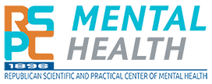
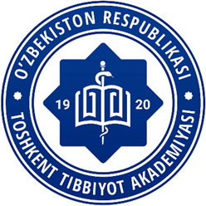

MINISTRY OF HEALTH OF THE REPUBLIC OF UZBEKISTAN

TASHKENT MEDICAL ACADEMY

RSE ON REM "REPUBLICAN SCIENTIFIC AND PRACTICAL CENTER FOR MENTAL HEALTH" OF THE MINISTRY OF HEALTH OF THE REPUBLIC OF KAZAKHSTAN

INTERNATIONAL SUBJECT OLYMPIAD IN PSYCHIATRY FOR MEDICAL STUDENTS
INFORMATION LETTER OF INVITATION
DEAR COLLEAGUES!
(October 11 , 2023, Tashkent, TMA)

On October 11 , 2023, at 9:00 am (Tashkent time), the Tashkent Medical Academy invites senior undergraduate students of medical universities to take part in
International Subject Olympiad in Psychiatry.
The official languages of the Olympiad are Uzbek, Russian and English.
The Olympiad will be held online .
For online participation, the link will not be sent to the email address you specified in the registration form.

The Olympiad is held in 3 stages:
Stage 1: Testing
Stage 2: solving a situational problem
Stage 3: Blitz poll on the Zoom platform
The number of students is not limited.

Registration for participation should be carried out through the social https://forms.office.com/Pages/ResponsePage.aspx?id=DQSIkWdsW0yxEjajBLZtrQAAAAAAAAAAAAN__kxPKJFUMkdNWFA0VTNUM0FZU1RJWEY0TTdDQkVFRS4u, then you must join the technical group https://t.me/+Ry78YKiHO0xhMjBi until October 9, 2023.

The Olympiad is held in 3 stages:
Stage 1: testing on the Google test platform
Stage 2: solving a situational problem
Stage 3: Blitz poll on the Zoom platform.
The number of students is not limited.
ALL STUDENTS WHO WANT TO DEMONSTRATE THEIR KNOWLEDGE AND SKILLS IN MEDICINE ARE
INVITED TO PARTICIPATE!

(details on the website of the Department of Psychiatry and Narcology TMA).

Contact information:
Userbayeva Roza Kuralbaevna, +998 97 424 01 52
